Monetary Policy

Five years of record low interest rates have deprived savers of £326billion, according to research.
The Bank of England is set to hold its base rate at 0.5% again later this week - marking the fifth anniversary it’s been at a historic low. The decision has given the economy a boost by driving down borrowing costs for businesses and many mortgage customers. But it’s hammered millions of savers who have seen the interest on their nest eggs plunge.
According to campaign group Save Our Savers, those with deposits would be £117bn better off if savings rates had remained at the level they were at in March 2009.
But savers have been hit with a double whammy because of rising inflation over the same period which has, the group estimates, reduced savers’ spending power by £209bn. The economic pick-up has been partly fuelled by savers who have raided their account to either make big purchases or to simply cover living costs.
Save Our Savers argues the current policy encourages people to take on debt , rather than put money away for a rainy day, which could cause trouble when rates start to rise.

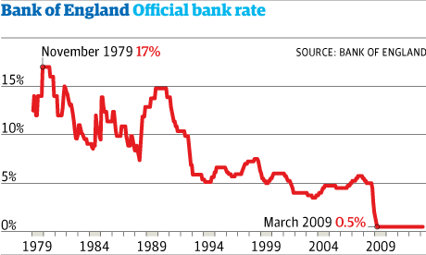
Simon Rose, from the group, said: “Low interest rates have not only savaged the nation’s savings, they have also exacerbated our dependency on debt. The Bank of England has been incredibly short-sighted in persisting with its low interest rate policy for so long.”
http://www.mirror.co.uk/money/city-news/bank-england-interest-rates-five-3204010#ixzz35qCnWYav
Questions:
- Define what is meant by an interest rate? (2 marks)
- Explain how the Bank of England have tried to change the level of demand in the UK since March 2009? (6 marks)
- Identify 2 ways in which an increase in interest rates could help reduce inflation? (6 marks)
- Do you believe the Government are right to keep interest rates so low, that savers can be worse off as inflation is above the rate of interest? (12 marks)

